**PROMETHE**US**-GRAFAN**A

**1.Configure Prometheus**

Create a user prometheus -

# useradd – prometheus

**Required directories-**

# mkdir /etc/prometheus

# mkdir /var/lib/prometheus

**Make prometheus user as the owner of those directories-**

# chown prometheus:prometheus /etc/prometheus

# chown prometheus:prometheus /var/lib/prometheus

**Download the source using wget**

# wget https://github.com/prometheus/prometheus/releases/download/v2.3.2/prometheus-2.3.2.linux-amd64.tar.gz

**Untar it.**

# tar -xvzf prometheus-2.3.2.linux-amd64.tar.gz

**Rename the extracted folder to prometheus-files**

# mv prometheus-2.3.2.linux-amd64 prometheus-files

**Copy prometheus and promtool binary from prometheus-files folder to /usr/local/bin**

# cp prometheus-files/prometheus /usr/local/bin/

# cp prometheus-files/promtool /usr/local/bin/

**Change the ownership to prometheus user by using chown**

# sudo chown prometheus:prometheus /usr/local/bin/prometheus

# sudo chown prometheus:prometheus /usr/local/bin/promtool

**Move the consoles and console_libraries directories from prometheus-files to /etc/prometheus folder**

# cp -r prometheus-files/consoles /etc/prometheus

# cp -r prometheus-files/console_libraries /etc/prometheus

**Change the ownership to prometheus user**

# sudo chown -R prometheus:prometheus /etc/prometheus/consoles

# sudo chown -R prometheus:prometheus /etc/prometheus/console_libraries

**Setup Prometheus Configuration**

Step1: Create the prometheus.yml file.

Go to # cd /etc/promotheus creat prometheus.yml file

# vi prometheus.yml

**Step2: Write following scripts on that prometheus.yml**

global:

scrape_interval: 10s

evaluation_interval: 15s

scrape_configs:

- job_name: 'prometheus'

scrape_interval: 5s

metrics_path: '/metrics'

static_configs:

- targets: [192.168.5.208:9090']

**Step 3: Change the ownership of the file to prometheus user.**

# chown prometheus:prometheus /etc/prometheus/prometheus.yml

**Note** **:**Whenever you do changes in prometheus.yml file .It is required to run Reload the systemd

# systemctl daemon-reload

**Step 4 : Create a prometheus service file. Write following scripts**

# vi /etc/systemd/system/prometheus.service

[Unit]  
Description=Prometheus  
Wants=[network-online.target](http://network-online.target/)  
After=[network-online.target](http://network-online.target/)  
[Service]  
User=prometheus  
Group=prometheus  
Type=simple  
ExecStart=/usr/local/bin/prometheus \  
--config.file /etc/prometheus/prometheus.yml --web.enable-admin-api \  
--web.listen-address=:9090 \  
--storage.tsdb.path /var/lib/prometheus/ \  
--web.console.templates=/etc/prometheus/consoles \  
--web.console.libraries=/etc/prometheus/console_libraries  
[Install]  
WantedBy=[multi-user.target](http://multi-user.target/)

# systemctl daemon-reload

**Start the prometheus service.**

# sudo systemctl start prometheus

**Start the prometheus service.**

# systemctl start prometheus

**Check the Status**

# systemctl status prometheus

**Note** **:** prometheus working fine it's ok Otherwise Check the .yml file & execute below commands

#systemctl stop prometheus.service

#systemctl status prometheus.service

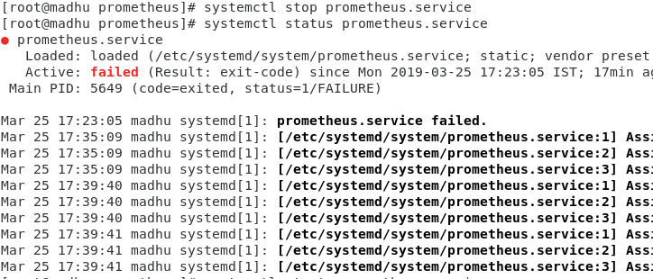

#systemctl start prometheus.service

#systemctl status prometheus.service

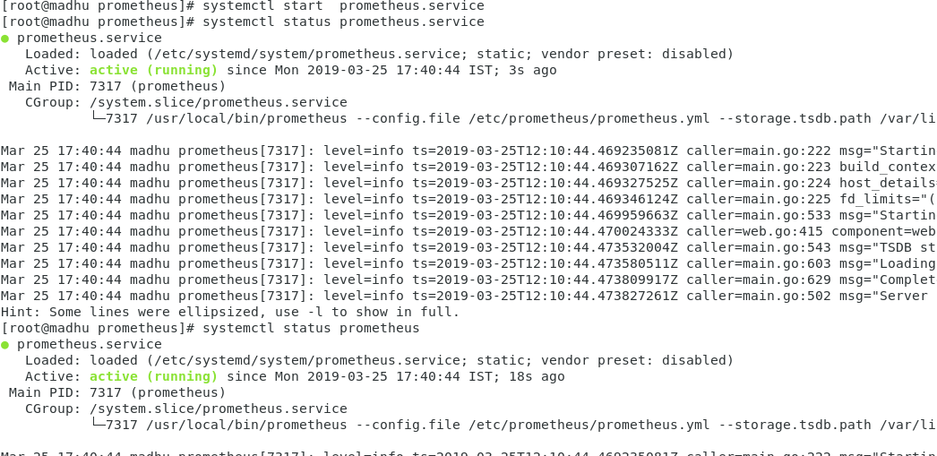

Now open in browser [http://192.168.5.208:9090](http://192.168.5.208:9090/) for Prometheus Dashboard.

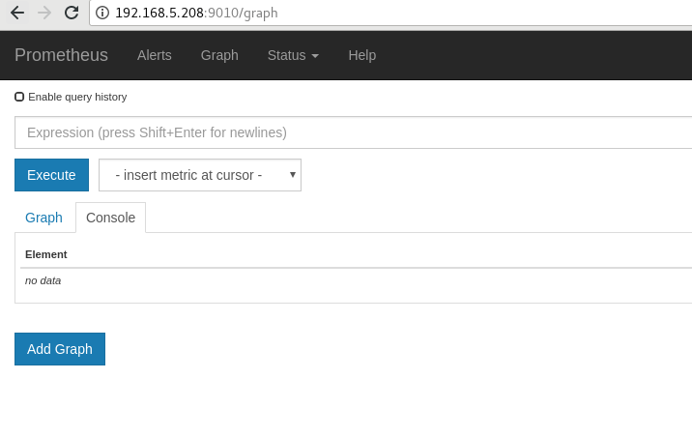You will get the dash board like this.

Prometheus port number is by default 9090. If u need to change the port number you can change in this path

# cd /etc/systemd/system

# vi prometheus.service

Add this to lines in to shown as below

--web.enable-admin-ap

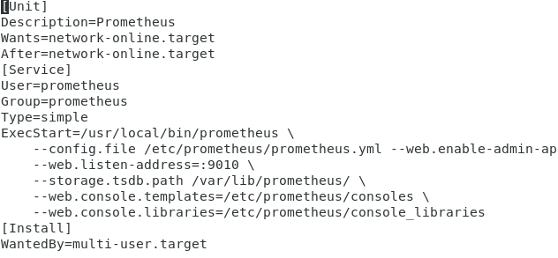 --web.listen-address=:9010 \In prometheus.yml file we need to add tomcat credintials (metrics) same as shown below.

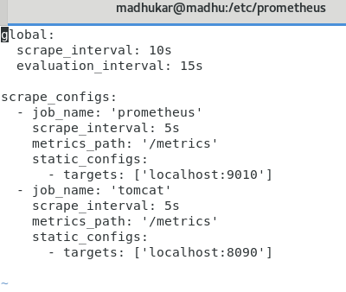

**Prometheus MONITORING for Tomcat Server**

1. download the 'tomcat_exporter_servlet' war file from

'<https://search.maven.org/search?q=a:tomcat_exporter_servlet>'

and rename the war with metrics.war and copy to webapp in tomcat server

2. download the below jar file from

<https://github.com/nlighten/tomcat_exporter>

Copy to **tomcat/lib** in tomcat server.

1. simpleclient_common-0.6.0.jar

2. simpleclient-0.6.0.jar

3. simpleclient_servlet-0.6.0.jar

4. simpleclient_hotspot-0.6.0.jar

5. tomcat_exporter_client-0.0.7.jar

**Restart the tomcat server & prometheus also.**

Now open in browser [http://192.168.5.208:9090](http://192.168.5.208:9090/) for Prometheus graph page

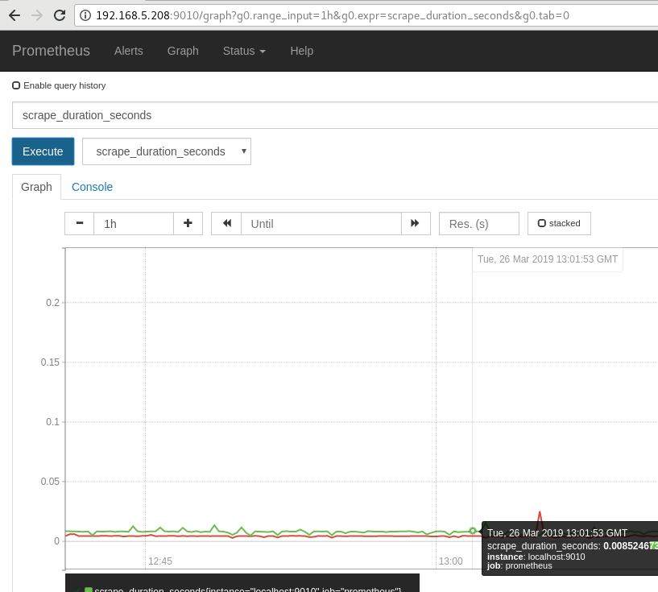

**2.Configure grafana.**

# yum install <https://dl.grafana.com/oss/release/grafana-5.4.2-1.x86_64.rpm>

# wget https://dl.grafana.com/oss/release/grafana-5.4.2-1.x86_64.rpm

# yum install initscripts fontconfig

**Create new repository for grafana and save it.**

# cd /etc/yum.repos.d

# vi grafana.repo

add this one into grafana.repo

[grafana]

name=grafana

baseurl=https://packages.grafana.com/oss/rpm

repo_gpgcheck=1

enabled=1

gpgcheck=1

gpgkey=https://packages.grafana.com/gpg.key

sslverify=1

sslcacert=/etc/pki/tls/certs/ca-bundle.crt

# yum install grafana

**Now Run garfana by using--**

# sudo service grafana-server start

**It can start at boot -**

# /sbin/chkconfig --add grafana-server

**To start at Boot:**

# systemctl daemon-reload

# systemctl start grafana-server

# systemctl status grafana-server

# systemctl enable grafana-server.service

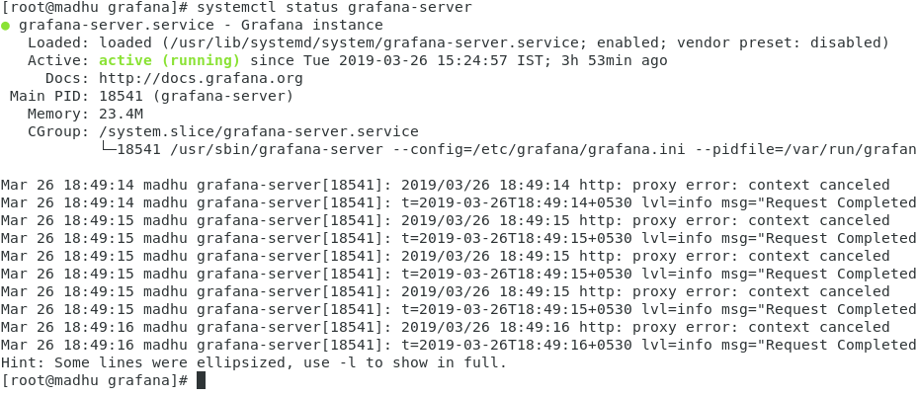Once grafana configured, go to 192.168.5.208:3000 It will log credentials

Default User name and password will be **admin/admin**

If u need to check u can Check this file—**etc/grafana/grafana.ini**

here u can change the poart number also

Go to Add Data Sources there find Prometheus.

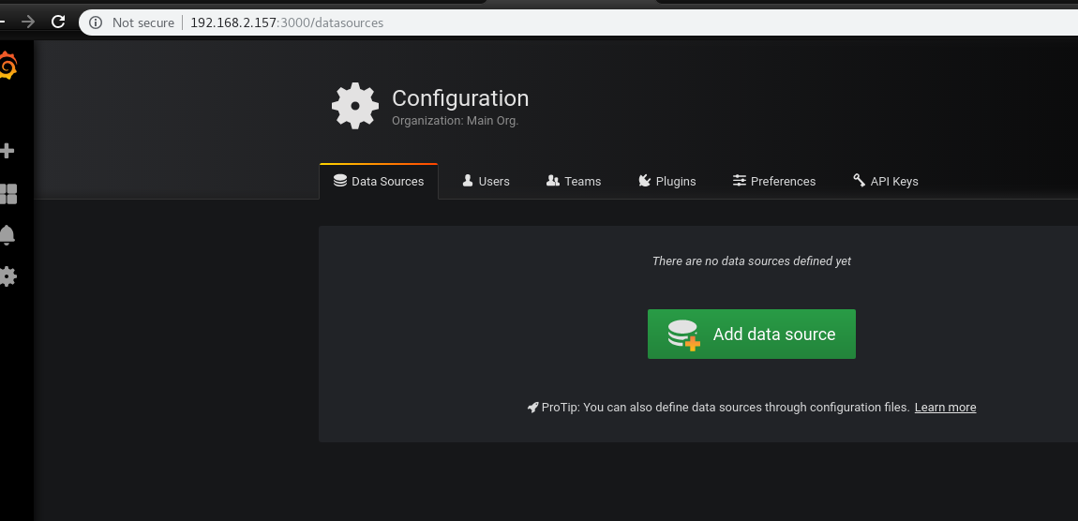

**Add Prometheus as data source.**

Enter URL & If it is correct it will show-Data source is Working.

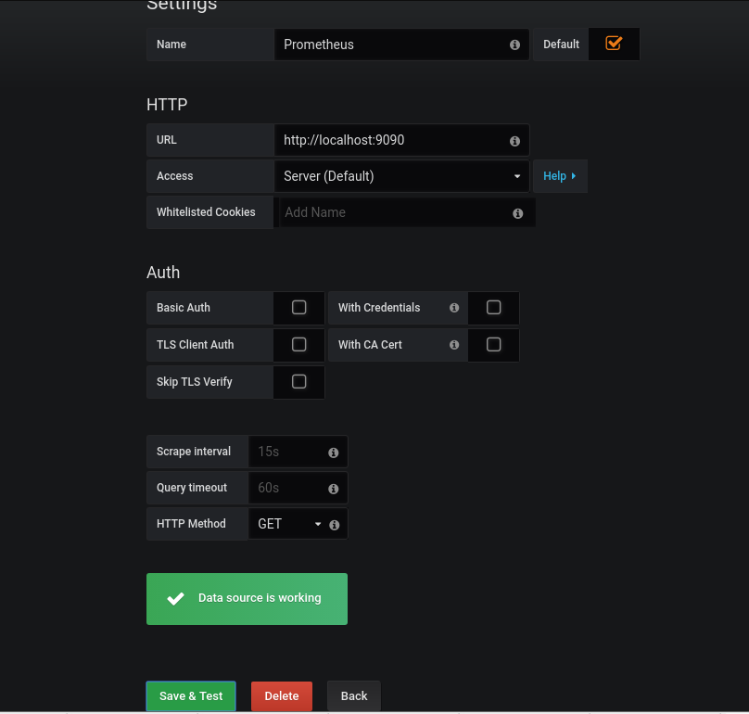

Here, You will get JVM Overview –--

Click on Copy Id clipboard copy – 3066

>Download .JSON file also

**Import JVM OVERVIEW.**

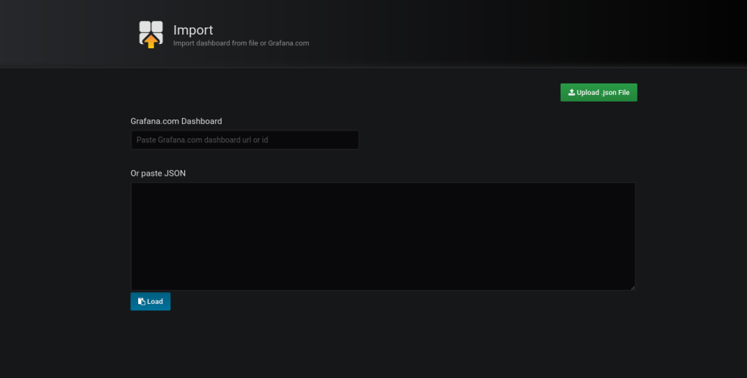

**Dashboard ID**

http://192.168.5.208:3000/d/fa1r1eqmz/jvm-overview-prometheus?orgId=1

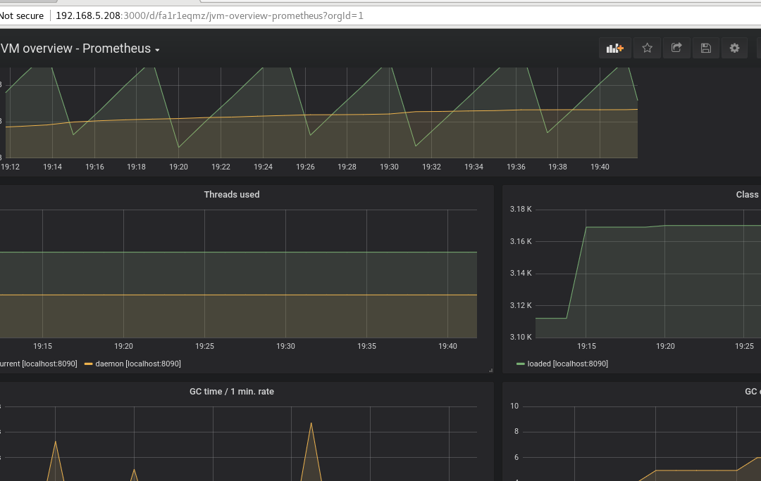

**Spring boot Application configurtion**

**cd /etc/prometheus**

**vim vi prometheus.yml (Add this below lines)**

**global:**

**scrape_interval: 10s**

**evaluation_interval: 15s**

**scrape_configs:**

**- job_name: 'prometheus'**

**scrape_interval: 5s**

**metrics_path: '/metrics'**

**scheme: http**

**static_configs:**

**- targets: [192.168.2.167:9090]**

**- job_name: 'spring-boot'**

**scrape_interval: 5s**

**metrics_path: '/pos-service/actuator/prometheus'**

**static_configs:**

**- targets: ['192.168.0.85:9095']**

**$ systemctl restart prometheus**

**$ systemctl restart grafana-server.service**

**and go to grafana dashboard and import the** *Spring Boot Statistics*

*using this url:-* [*https://grafana.com/dashboards/8813*](https://grafana.com/dashboards/8813)

